Duplicate Training Data Model:

- 20 LSTM nodes on each layer

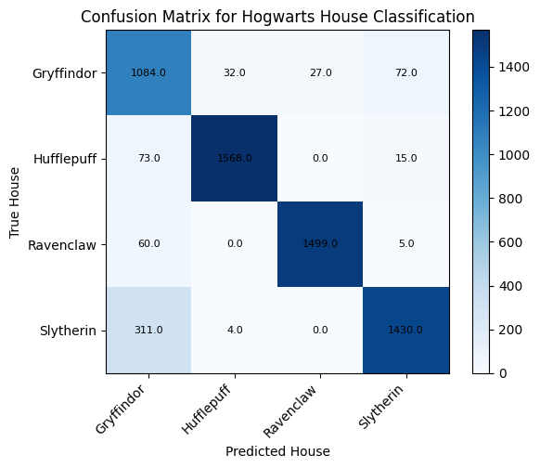

Gryffindor Percentage: 70.94240837696336%

Hufflepuff Percentage: 97.75561097256858%

Ravenclaw Percentage: 98.23066841415465%

Slytherin Percentage: 93.95532194480947%